“You Can Change the World”: Environmental Advocacy and Media in 1970s Alberta

Lillian Agnes Jones Scholarship
Whyte Museum of the Canadian Rockies
Final Report

By Chris Chang-Yen Phillips
May 2025

Table of Contents

Table of Contents: 2
Introduction 3
Parks for Tomorrow 7
Strategic lessons from Village Lake Louise 8
Getting the band back together 10
Hilary McDowall 15
From Bletchley Park to the Rockies 16
“Noisy opposition based in ignorance” 20
The Whale Society of Edmonton 24
A bit about Jaclyn Dorsey 25
Taking to the (radio) waves 28
Writing about Whale School 29
Conclusion 33
Acknowledgements 34

Introduction

As a sometimes-journalist, I get a sinking feeling about my profession when I think about an article in the St. Albert & Sturgeon Gazette about the Bighorn Dam. It was 1972. Calgary Power invited reporters to see the final gates installed in their new hydroelectric dam near Nordegg. Gazette reporter Ernie Jamison wrote fawningly about seeing the reservoir’s creation from a Calgary Power helicopter, and how much fun he had on a fishing trip the company hosted “to relieve the collective minds of the media people of technical and ecological impact[s] of the project.” Jamison neglected to mention that local Stoney Nakoda leaders had been trying for years to save their hunting grounds, graves, and history from being flooded by the reservoir.
As an environmental historian, I’ve learned about other examples of Alberta journalists dismissing environmental issues and their advocates from Shannon Stunden Bower’s research. In 1965, a mostly-female group of activists in Edmonton tried to stop a freeway from being built through their ravine. Stunden Bower noticed that newspaper articles dismissed them as just “housewives” until men joined in. Stories like this make me wonder why activists ever talk to journalists at all. Yet Louise Swift’s writing about anti-nuclear and anti-pollution activists in the 1960s and 70s suggests that they saw radio, newspaper, and television coverage as a crucial part of their consciousness-raising work.
This article is the main product of my research at the Whyte Museum of the Canadian Rockies, supported by the Lillian Agnes Jones Scholarship. I set out to better understand how and why small environmental groups in Alberta interacted with media in the 1970s, and how media covered their work. One reason I think it’s worth thinking about this time is that it was a uniquely hopeful moment for environmentalists in this province. Grassroots activists pushed Alberta’s Social Credit government to create an Ecology Corps and provincial environment department in 1971. Successful campaigning against the Village Lake Louise ski development in 1972 was a turning point in public input in Canadian national parks policy, according to Qi Chen and PearlAnn Reichwein.
Much of this advocacy was done by groups with two hundred members or less. Jonathan Clapperton and Liza Piper have observed that around North America, small activist groups offered more prominent roles for workers, women, Indigenous activists, and other marginalized groups than bigger environmental organizations. A lot of these groups focused on national and provincial parks, and their work is under-studied. Jessica M. DeWitt has noticed that histories of parks have mostly focused on big institutions and elites, while “the voices and unique experiences of the citizens for whom the parks were supposedly created are often pushed to the background, glossed over, or ignored completely.”
In this article, I use three case studies to explore these issues. The first case study looks at the activists who organized the Parks for Tomorrow march in 1977, and how they critiqued their own press strategy. The second looks at Lake Louise-based journalist Hilary McDowall, who showed increasing frustration with campaigns against ski tourism projects. Since parks can be unusual places, my final case study looks at how one urban group used media coverage: the Whale Society of Edmonton.
Whyte Museum records provide the foundation of my study, especially from Bow Valley Naturalists’ files about the Parks for Tomorrow group, and the Hilary McDowall fonds, which includes copies of many of her articles. I examined the Whale Society of Edmonton’s work through their fonds at the City of Edmonton Archives, newspaper clippings, and one phone interview.
The activists in these case studies showed sophisticated understandings of how to get media attention and how it fit into a broader theory of change. In short, they believed that public opinion mattered to elected officials and bureaucrats, and that mainstream media could help them reach a critical mass of allies and channel their voices to influence government decisions. In a time when some governments seem impervious to public outcry, this relationship should not be taken for granted. Hilary McDowall’s records are a fascinating window into the other side of this relationship, and invite complicated questions about reporters’ livelihoods in small mountain park communities.

Parks for Tomorrow

The most unusual thing about the Parks for Tomorrow march through Banff in 1977 wasn’t the 200-250 protesters who put up with the rainy October weather. It wasn’t their signs with slogans like “Sunshine Don’t ‘Shine’ in the Alpine” and “Parks Are Going to the Cows!”. It was the fact that both CTV and CBC sent news vans out from Calgary to film the march. A grip apparently told CTV reporter Barbara Amiel, “Maybe it’ll be a stand-off between you and Adrienne Clarkson.”

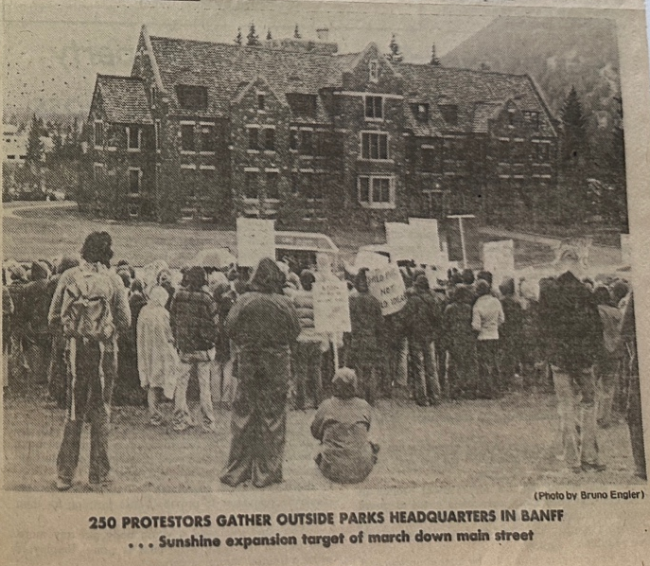
Prominent newspaper coverage of the Parks for Tomorrow march. From: “Marchers protest Sunshine expansion,” Calgary Herald, October 24, 1977.

Parks for Tomorrow was a coalition of scientists and environmental groups from across Canada who came together to protect national parks from commercial exploitation. Most urgently, they wanted to stop expansion of a ski resort in Banff National Park, and cattle grazing and haycutting in Waterton and Prince Albert. Their campaign was centred around a march down the streets of Banff on October 23, 1977. Parks For Tomorrow organizers saw the presence of TV crews and newspaper reporters as a major win. Conservation groups from across Canada endorsed the Parks For Tomorrow demands, claiming to represent over 750,000 members altogether. The ground-level organizing work was done by a small group of volunteers, many from the Banff-based Bow Valley Naturalists. Looking back through their notes, we can learn why they valued media coverage so highly – and ask how much these lessons would apply outside of a park.

Strategic lessons from Village Lake Louise

The Bow Valley Naturalists (BVN) society was founded in 1967 by locals interested in learning about natural history and protecting Rocky Mountain natural areas and wildlife. A decade later the group had about 90 members. Most of the BVN’s first presidents were men, including Jon Whyte, Mike McIvor, and Geoff Holroyd. Women played prominent leadership roles too though, including Muriel Gratz as president and Aileen Harmon as vice-president. Members organized hikes and field trips, species counts, litter cleanups, and advocacy campaigns. They also hosted films and guest speakers.
One influential speaker was Stephen Herrero, a University of Calgary professor in environmental studies. At a November 1969 talk, he told BVN members that there was a dire need to protect existing national parks and create new ones. According to meeting notes, he encouraged attendees to write to their Members of Parliament and government officials if they wanted to get involved, since “public opinion was a major influence on government decisions.” This advice seemed to resonate. Over the next few years, BVN focused on persuading national park officials by writing letters, submitting an annual “State of the Park” policy brief, and making statements in newspapers and public hearings.
These strategies helped defeat a huge tourism project in Lake Louise. In 1971, a company known as Village Lake Louise Ltd. (jointly owned by Imperial Oil and Lake Louise Lifts) put forward a $30 million proposal to expand ski tourism facilities within Banff National Park at Lower Lake Louise. The Village Lake Louise plan would include a year-round visitor service centre, accommodations for 3000 visitors and nearly as many staff, drug stores and night clubs, a library, and more. As Qi Chen and Pearl Ann Reichwein have written, the federal government had been trying to attract investment in year-round visitor services for over a decade, “to relieve tourism pressures on Banff townsite.” The National and Provincial Parks Association of Canada (NPPAC) raised the alarm about the proposal. They argued that no environmental impact studies had been done and that it would only serve rich ski tourists. In February 1972, BVN invited guest speakers for and against the plan, and concluded public sentiment was against it.
When public hearings were held that March, BVN joined scientists and other conservation organizations in speaking against the Village Lake Louise plan. The NPPAC also organized petition letters, radio and television spots, and an Esso boycott to pressure its owner, Imperial Oil. Herrero was head of an NPPAC committee studying the project, and told the Canadian Press that “its approval would create a precedent for similar resorts in other parks.” Jean Chrétien was the minister responsible for the Parks Branch at the time, and in July 1972 he rejected the proposal, concluding it would lead to an unacceptable level of environmental impairment. To this day, environmental groups see the decision as a major victory for wilderness protection and public participation in park policy.

Getting the band back together

In 1977, many of the same environmental groups, scientists, and individual activists came together to fight what they saw as increasing commercial exploitation and political manipulation of parks. BVN President Geoff Holroyd helped rally them to form the Parks for Tomorrow coalition. Other key organizers included Herrero, the BVN’s Mike and Diane McIvor, AWA President Ray Sloan, and Dorothy Broadbent from the Red Deer River Naturalists. “Two issues had sparked the coalition’s desire to go beyond the normal avenues of letter writing and dialogue,” says BVN historian Margery McDougall, “which had until then produced only frustration.” One was the parks minister’s approval of a Sunshine Village ski area expansion that would triple visitor capacity. The other was the decision to allow cattle grazing and haycutting in Waterton and Prince Albert National Parks.
Parks for Tomorrow organizers still had faith that public opinion could sway bureaucrats and elected officials, but believed that the public outcry needed to be much louder. They hoped that a high-profile protest in Banff would channel voices from across Canada, and that news coverage would make sure their message was heard. Herrero wrote to every conservation group in the Canadian Nature Federation’s national index to ask for their support. Many lent their endorsement, from the twenty members of the Save Howe Sound Committee to the 400,000 people in the Ontario Garbage Coalition’s member groups.
The organizers decided to reach beyond their usual friendly media outlets for this event – to national newspapers and to TV stations like CBC Edmonton and Calgary, CTV, and the provincial Access channel. Before this, BVN seemed to target media outreach on small local newspapers like Canmore’s Valley Views or Banff’s Crag and Canyon, which would run positive stories about their nature surveys, or publish their opinion pieces and meeting notices. Occasionally, they would submit editorials to papers with a larger reach like the Edmonton Journal, or to sector-specific publications like the Foothills Wilderness Journal. The Parks for Tomorrow team seemed to struggle figuring out what the bigger outlets would need, or when to provide it. “Press coverage,” Holroyd wrote in the notes for one planning meeting, “was discussed last + not well defined.”
I think the organizers underestimated the value of two other choices they made. One was to scrap a potential wake with a coffin after the march, because Holroyd and Mike McIvor “found that a negative public backlash occurred after a similar event at the proposed Red Deer River dam site.” Second, they decided not to walk to the ski resort site at the Sunshine Meadows the day before the march. I suspect the coffin would have made it easier for media to portray them as extremists, and the meadows would have been too far away for Calgary reporters.
In the end the campaigners got most of the media attention they were looking for. CBC and CTV both sent TV news crews from Calgary, and radio stories aired on CBC, CFCN, and CKXL. Though I could not find copies of these clips to hear their tone, print reporting was sympathetic. We can measure this by the length of articles, their use of photos, and whether they were close to the front page or buried at the back with the classified ads. Reporters can also express skepticism of interviewees’ claims by using “scare quotes” around key words, or by paraphrasing them to reject their framing.
The Canmore Miner dedicated a full page to a preview of the march, with extensive quotes from Holroyd and Mike McIvor. The Calgary Herald wrote a preview that largely quoted Ray Sloan directly, except to raise an eyebrow at his concerns about the parks minister’s “decision to ‘commercialize’ western parks.” Even the right-leaning Albertan published a preview on page 3 with quotes from Dorothy Broadbent.

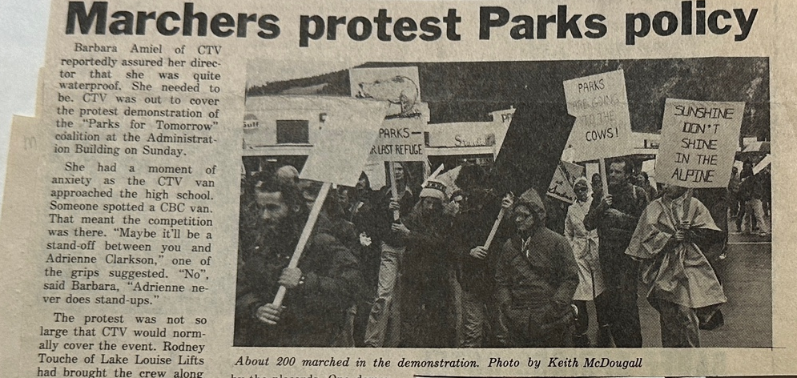
Local coverage of the march. From: “Marchers protest Parks policy,” Crag and Canyon, October 26, 1977.

After the October 23 event, articles were even more favourable. The Crag and Canyon gave it front page coverage, with a photo of protesters close-up enough to see their rain ponchos and read their signs. A Herald article included a large photo of protesters in front of Banff park headquarters. “The marchers slogged through rain,” the reporter said, “to present parks superintendent Paul Lange with briefs and a petition signed by more than 20 naturalist groups representing about 750,000 people across Canada.” For environmental activists, it’s a good day when a major Alberta newspaper portrays you as ordinary people putting up with bad weather to present reasonable concerns.
Still, the organizers found flaws in their strategy. They didn’t have a press release ready before the march, and the one after the event went out too late. “There was no systematic approach to all press TV, radio, newsp[apers,]” one organizer said. Team members’ criticism of the march itself was even harsher: “unorganized, no loud speaker at first,” someone said, and “crowd needed something to cheer at – next time – one liners to get a reaction.” No one was in charge of ending the speeches, and there was no press conference the next day. Should they try for the next week, they wondered?
The Parks for Tomorrow members were probably too hard on themselves. They attracted positive media coverage by organizing a photogenic event with endorsements from groups representing hundreds of thousands of Canadians. Marching in Banff’s townsite probably gave them unique advantages too, since Banff National Park was a popular tourist destination, close enough for Calgary reporters to reach, and symbolic of national issues. No matter how well-organized the end of the march was though, the reporters would have been long gone. Journalists on a deadline usually only stick around long enough to get good shots and a few choice quotes.

Hilary McDowall

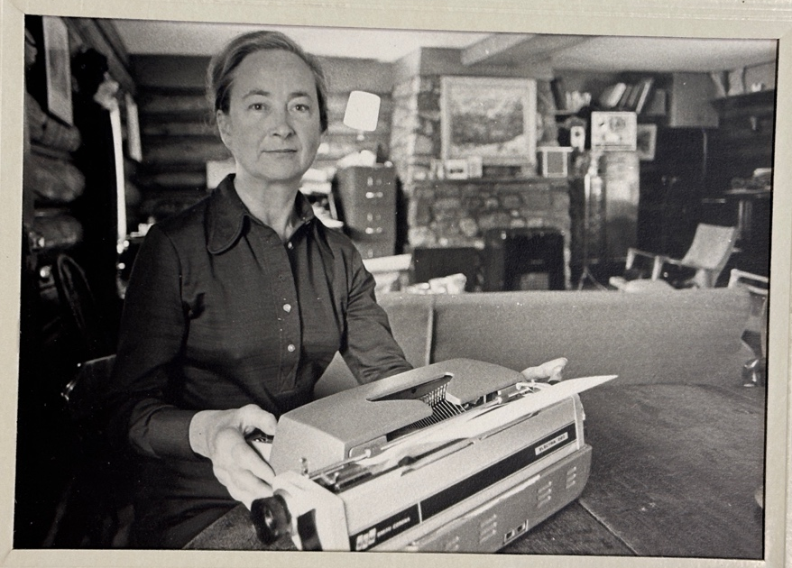
A portrait of Hilary McDowall from the Calgary Herald. From: Notebooks, photos, and letters. 1960-1983. Hilary McDowall fonds. M66. Archives and Library, Whyte Museum of the Canadian Rockies.

Hilary McDowall’s writing is another fascinating window into the relationship between journalists and environmentalists. She served as the Calgary Herald’s Lake Louise correspondent, and as sole publisher and editor of a tiny publication called the Kicking Horse News. Hilary and her husband Jack lived in the village year-round, letting her offer readers a unique window into local characters, mountain delights, and the seasonal rhythms of the ski resorts. From the mid-1960s onward, she wrote very critically about environmentalists who opposed bringing the Olympics to the area and expanding housing and highways. There was some key information she chose not to share with readers, though. Her story hints at dilemmas in reporting from a small community in a national park.

From Bletchley Park to the Rockies

Hilary had an improbable path to becoming a journalist in the Rocky Mountains. She was born in 1920 in the English town of Luton. Her parents were not wealthy, but she earned a scholarship to attend Oxford University and studied French and Italian. The Second World War had erupted by the time she finished her MA, and she was recruited to the British Admiralty intelligence section at Bletchley Park, famous for its work decoding German signal intelligence. On top of translating from Italian and French, she learned German on the job. After the war Hilary taught Italian literature at University College London, which is where a colleague introduced her to a factory production engineer named Jack McDowall.
They got married in 1948 and soon decided to leave England. Apparently, Hilary told Jack that if he agreed to go to Canada, he could decide where to go. He found work in Lake Louise, and they arrived in 1951. It must have been quite a drastic change: Hilary had to make a complete career shift, and gave birth to their daughter Catherine a few months later. Their Lake Louise cabin was rustic. “Between September and May, life seemed an unending round of filling things,” she later wrote: “tanks with water, cookers with coal, stoves with oil, lamps with coal oil or high test gas.” She seems to have rolled up her sleeves and made it work though, and found pleasures in living in the park – like writing.
In the early 1960s, Hilary became the Calgary Herald’s Lake Louise correspondent, contributing stories about tourist attractions, the hardiness of Lake Louise residents, and the accomplishments of scientists. She wrote about a glaciologist, for example, who got trapped on Peyto Glacier “in a raging storm with no heating and nothing to eat but frozen carrots.” In other articles, she wrote about visiting the Spiral Tunnels, challenges at the one-room school, and work preparing the Chateau Lake Louise for summer guests.
Activism wasn’t a focus in her Herald reporting, but she did write about controversial park policies like the restrictions on private home ownership. She quoted ski lodge owner Norman Watson as saying, “You can not run a year-round resort on transient labor.” Sir Norman, as she called him, was a British aristocrat and veteran pilot who became owner of properties like the Mt. Temple Chalet and the Post Hotel after falling in love with the Rockies.

Hilary served as the Herald’s Lake Louise correspondent until 1966, when she regretfully told her editor that she was too tied up with other business to send news regularly. She hoped to keep putting out her own paper though: the Kicking Horse News.
The Kicking Horse News was much smaller and spunkier than the Herald. It spun off from a short-lived weekly paper called the Kicking Horse Chronicle. The Kicking Horse News ran from 1962 – 1972, and Hilary was the editor, publisher, and chief contributor. Superficially, its focus on Lake Louise and Field resembled other small Rocky Mountain periodicals like the Jasper Booster or Valley Views. The News had no regular publishing schedule though, coming out every month to three months. It also had no paid subscribers, ads, or government funding. Instead, it relied on donations from individuals and businesses like local printers and Lake Louise Lifts. The News also invited readers to send in a small donation to cover postage. The distribution list was small – about 150-200 – but included subscribers as far away as Hawaii, Indonesia, and Uganda.

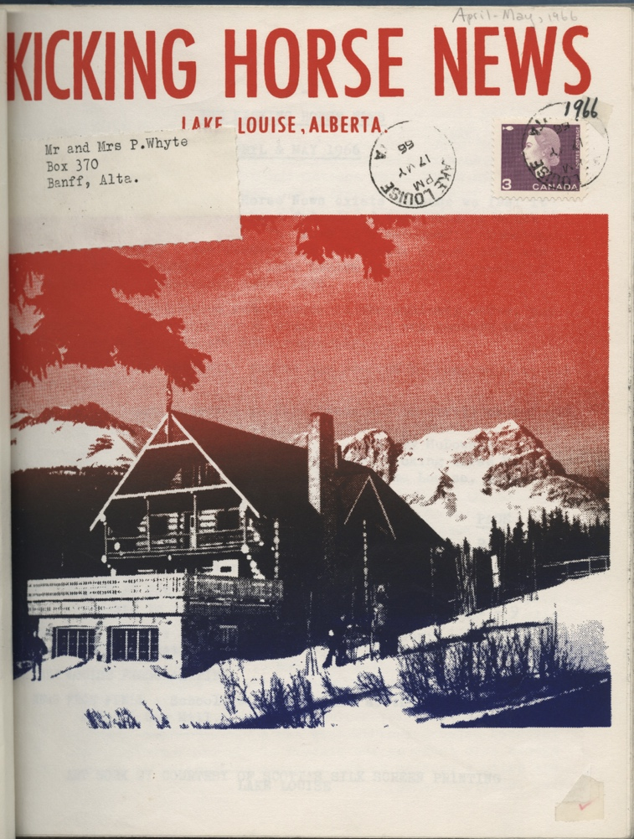
Scott’s Silk Screen Printing in Lake Louise helped sponsor colour printing for the Kicking Horse News covers. From: Kicking Horse News, April - May 1966.

Part of the appeal for distant readers must have been the News’ wry coverage of local characters, like dishwashers in Banff caught leaving fresh pies on garbage cans for fellow hippies, the Arab-German couple running Field Grocery, and the bear “prowling hippy-like round the empty cabins of the Motel Lake Louise” one December. Kicking Horse News readers also encountered a side of Hilary McDowall that was more openly hostile to environmental groups and the federal government.

“Noisy opposition based in ignorance”

One issue that exasperated her was opposition to bringing the Winter Olympic Games to the area. Calgary bid unsuccessfully for the 1964 and 1968 Olympics, which would have hosted events in Banff. Banff itself was a candidate for the 1972 Olympics, and Lake Louise’s ski hills and roads would have been expanded for the Games. Many conservation groups called on the federal government and the International Olympic Committee (IOC) to reject the bid, arguing that construction would cause unacceptable destruction to natural features in the park. These included small Alberta groups like the Edmonton Nature Club as well as large organizations like the Canadian Society of Wildlife and Fishery Biologists and the National and Provincial Parks Association of Canada (NPPAC). In 1966, the IOC voted to award the 1972 Games to Sapporo instead.
Hilary wrote scathing editorials blaming wildlife conservationists for this defeat, describing them as outsiders from places like Toronto and New York who knew nothing about human-animal relationships in a game preserve. “Honourable in their intent, ill-informed in their opinions, unbalanced in their judgements, self-satisfied and savage in their intolerance, they were happy to stigmatize as sordid and mercurial the efforts of those who were labouring for this national goal,” she wrote. “As the Lake Louise ski area manager put it, ‘Seldom has so much benefit for so many been frustrated by so few.’”
Her frustration was just as high in 1972, when the federal government rejected the Village Lake Louise proposal from Imperial Oil and Lake Louise Lifts. Hilary supported the plan, with reservations. In a Kicking Horse News editorial, she said more year-round facilities for visitors and staff were overdue, but that development needed to go slower to be commercially feasible. She also thought it would look jarring to put so many buildings into a tiny space. “It is as if the planners felt that any gain on the environment by man was inevitably a loss to nature,” Hilary wrote. “Hence the development must be kept to a severely limited area, so that the planners can say to the nature lovers, ‘All right, we’ve ruined half a square mile, but we’ve left you all the rest.’” Genuine Alpine villages were more spread out and blended into their surroundings, she said, showing that “it is perfectly possible for man to cater to his own reasonable wants and still be in harmony with nature.”
Hilary was clearly wounded when the federal government rejected the plan. In an October 1972 editorial, she argued that Minister Chrétien only bowed to “noisy opposition […] based in ignorance” because an election was coming up. “We do not know how the idea originated that the Lake Louise Lifts – Imperial Oil proposal provided only for the rich,” she wrote, but the fear of high prices was already scaring visitors away. And in all the publicity, she said, nobody had mentioned that Lake Louise residents were already suffering from a lack of housing and ordinary amenities.
What Hilary chose not to mention was her own connection to the proponents. Her husband Jack had been managing director of Lake Louise Lifts and its parent company, Ski Club of the Canadian Rockies, owned by Norman Watson. This was actually why they moved to the park: because Watson offered Jack work building ski lifts for his resorts. Lake Louise Lifts was also one of the businesses that sponsored the Kicking Horse News in its early days. Hilary, meanwhile, had worked as a bookkeeper and accountant for Watson’s Post Hotel, where Jack was a manager. These relationships were never explicitly disclosed in Kicking Horse News coverage of the Village Lake Louise proposal, nor in articles Hilary wrote for the Herald defending Watson’s reputation.
In a community as small as Lake Louise, it was inevitable that the McDowalls would have some financial relationship with the ski industry. Given the policy preventing privately-owned housing in Banff National Park, she and Jack could only live in Lake Louise as long as they had work nearby. Living in the park gave Hilary a unique insider’s look that served readers in Calgary and beyond. After the Village Lake Louise plan was defeated, Jack left his job with the Post Hotel and the couple moved to Kaslo, BC. She let the Kicking Horse News die with their departure.

Hilary McDowall’s records offer a rich look at how one journalist covered small environmental groups’ campaigns in Alberta during the 1970s. Her frustration with these activists was understandable, and her conflicts of interest might have been forgivable – if she’d disclosed them.

The Whale Society of Edmonton

If you’re wondering whether it makes any sense to run a save-the-whales group from the prairies, it’s worth considering the fan art that young Judith Taylor sent to the Whale Society of Edmonton in 1979. There’s the dolphin she drew in dark blue marker, swimming sideways with classic squiggly waves. Adorable. The seagulls are sweet too – five tiny brown crosses flying through the sky. But what makes the picture an all-time classic for me is what Judith wrote underneath, beside her name and phone number: “I like a whale. I Love a whale.” This drawing clearly touched somebody at the Whale Society too, because they tucked it into the organization’s membership list for the year.

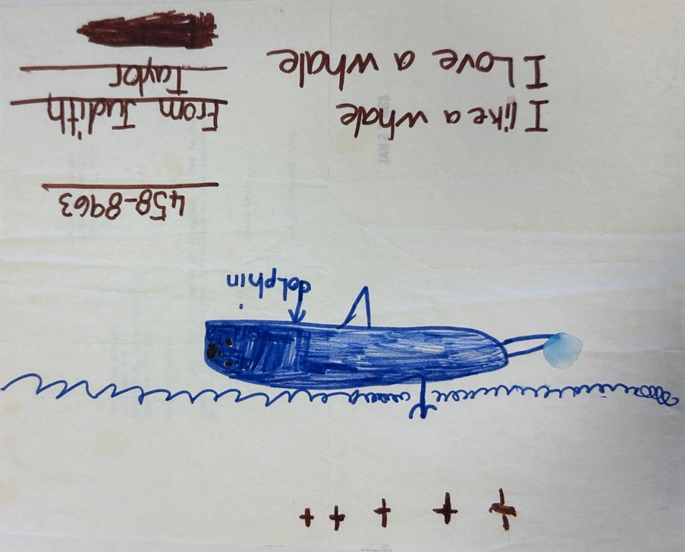
Many children sent cetacean fan art to the Whale Society. From: Judith Taylor to Whale Society of Edmonton, n.d., Membership, 1979 – 1984, Whale Society of Edmonton Fonds, MS 358-28, City of Edmonton Archives.

Yes, thousands of kilometres from the nearest coastline, a group of Edmontonians ran the Whale Society of Edmonton from 1979 – 1984. For five years, they led public education programs about whales and dolphins, and advocated for their protection. “A lot of people here haven’t ever seen a whale,” said their president, Dennis Wighton, “but they have a feeling, ‘for God’s sake, leave them alone, I want them to be there’.” Improbable though it may seem, the Whale Society attracted about 200 members in their first year. Their ranks included many women, some people of colour, and about two dozen kids. They showed a sophisticated understanding of policy goals and how to use media to move people to action.

A bit about Jaclyn Dorsey

The Whale Society’s goals and methods are revealed in letters that Secretary Jaclyn Dorsey wrote to prospective members, preserved at the City of Edmonton Archives. From these records, we can see that she found joy, tenderness, and respect in learning about minkes and orcas. The federal government’s defense of whale hunting, meanwhile, gave her a kind of shame and astonishment recognizable to many environmentalists.

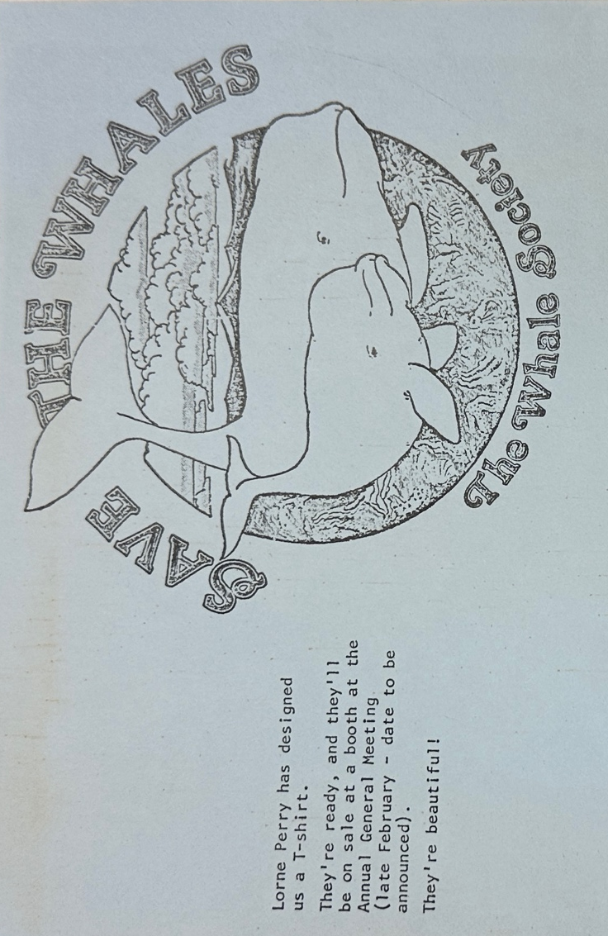
A Whale Society T-shirt design from the 1981 membership drive. From: “Membership Renewals,” Membership, 1979 – 1984, Whale Society of Edmonton Fonds, MS 358-28, City of Edmonton Archives.

Though Jaclyn has passed away, her younger sister Candas Jane Dorsey spoke to me about their roots. Candas was the youngest of three, and is herself an accomplished writer, activist, and teacher at MacEwan University. “We didn’t really have models of meek, quiet women in our family,” she says. “You did what you were good at, and you did it to the best of your ability, and it didn’t matter if you were male or female.” All of the siblings “started out our lives thinking you have to live according to your ideals and your values,” according to Candas.
Candas remembers a much more hopeful attitude towards environmental crises in general in the 1970s. “At the time, we sort of believed that not only could you fix it, but that people wanted to,” she recalls. “Whereas today, the people I’m teaching, they’ve got to get their heads around the fact that some of these assholes don’t want to fix it. They literally can’t be shamed.” Young people - hippies - in Western Canada felt a great sense of possibility, captured in the gentle melody of songs like the Pied Pumkin String Ensemble’s “You Can Change the World.” If they thought of something that could help save the world, says Candas, they just knew they had to do it.
As for Jaclyn, activism was just one part of a very full and creative life. “The things she did for money weren’t central to her identity," according to Candas. Jaclyn was also a visual artist and musician, and around the time of the Whale Society’s formation worked as secretary for the biochemistry department at the University of Alberta. Why put her energy into volunteering as secretary for a whale organization in a landlocked place? Candas says her sister probably just assumed it was a necessary thing. “That of course you try to save the whales, and it doesn’t matter where you live.” Optimism came to Jaclyn, she recalls, “but not always easily.”

Taking to the (radio) waves

The Whale Society of Edmonton launched in March 1979, and they were soon “plunged full-tilt” into trying to change the world. Canada had already stopped commercial whaling by this time, but the Whale Society wanted Canada to support a global moratorium against whale killings. Like the Parks for Tomorrow organizers, the Whale Society believed that public pressure could make a difference. They zeroed in on the Canadian delegation headed to an International Whaling Commission meeting that July. In a letter to a supporter, Jaclyn explained that half of the Whale Society’s strategy was presenting a brief to the delegation in Ottawa. The other half was getting Canadians to send postcards in support of a moratorium. With precious little time, the Whale Society used broadcast media to spread the word about their campaign.
CKUA – an Alberta-wide public radio station – helped their message reach Albertans like Sheila Marks of Hines Creek. “I too consider myself a friend of the whales,” she wrote, “and would like to express my support for an end to the Whaling Industry.” Marks reached out after hearing CKUA host Bill Koul talk about the Whale Society on his program, Producer’s Choice. “I have written my support to the Canadian Delegation to the International Whaling Commission in Ottawa,” she added. Listeners in Medicine Hat and Slave Lake wrote similar letters.

Deciding whether this campaign succeeded depends on how far you want to zoom in. In extreme close-up, the Canadian delegation’s records from the 1979 IWC meeting don’t mention the Whale Society postcards and brief. Canada abstained from the vote on a whaling moratorium, and the proposal failed. Still, Canada supported a successful vote to stop factory ships from hunting whales, except for minkes.
Media attention about the Whale Society campaign got Albertans to participate and ask how they could stay engaged, though. The group continued to pursue coverage in major newspapers, TV, and radio stations to recruit new members and educate the public about cetaceans. Newspaper articles often treated the Whale Society’s existence as a neat oddity and educational opportunity for Albertans.

Writing about Whale School

Like other activist groups, Whale Society members also wrote about their own work in smaller publications like their newsletter and the NPPAC’s Park News. With a friendlier audience and more control of the narrative, they could explore the science, wonder, and outrage that drove their campaigns. One example is an article that Jaclyn Dorsey wrote for Interface in 1980 about her week at “Whale School” in Washington State’s San Juan Islands. Interface was a small arts magazine published in Edmonton and Calgary. Jaclyn wrote about her awe holding a bottlenose dolphin skull with a braincase bigger than a human’s. “What are the ramifications of that?” she wondered.

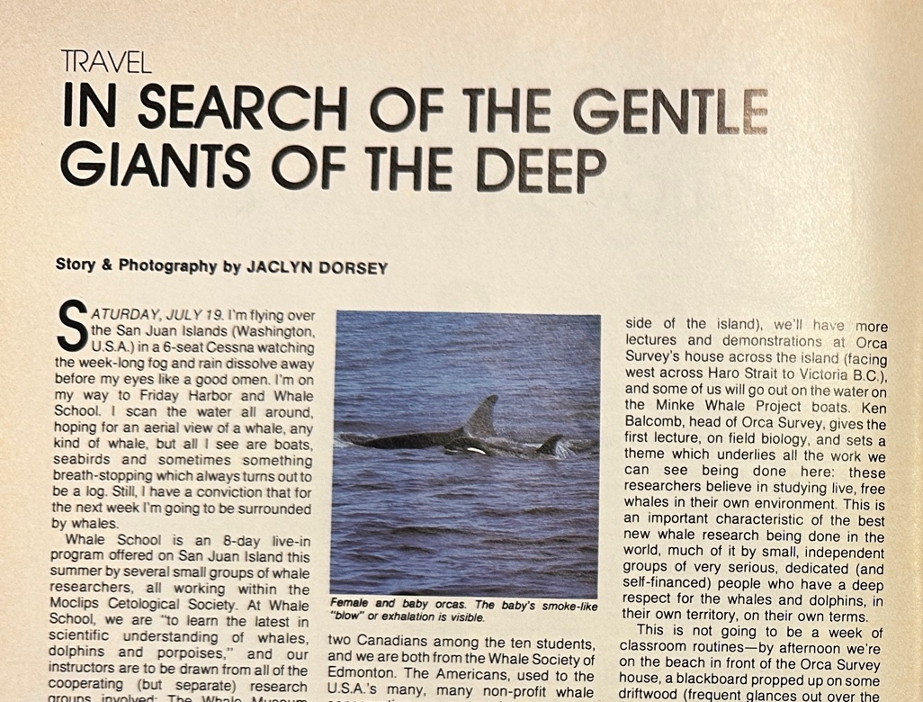
An excerpt from Jaclyn Dorsey’s story about encountering whales on the west coast. Source: Jaclyn Dorsey, “In Search of the Gentle Giants of the Deep,” Interface, September 1980.

Interface gave her four pages for the story, with colour photographs of orcas. That space allowed her to explore the gulf between the vast unknowns of whale behaviour and the certainties of hunting quotas. After a whole day on a minke research boat, she only caught three quick glimpses of their fins. “I find in my heart a very soft spot for that elusive being which suddenly and oh so quietly slips a fraction of its back out of the water and then is gone again,” she wrote. Later, she captured the “throat-stopping realization” that minkes were now a hunting target because bigger whales had disappeared. Jaclyn described her shock learning over a campfire supper that Canada cast a deciding vote against a sperm whale hunting moratorium. “That my own country aligns itself with the whalers sends my feelings skating through amazement, through shame, to end up somewhere in angry frustration.”
Jaclyn wrote that this experience made her more resolved to bring stories and photographs back to enrich the Whale Society of Edmonton’s work. Underneath, it seems like she doubted whether that work was making a difference. The article moved at least one reader deeply, though. A University of Alberta student named Tracy Romanko wrote to the Whale Society to say how thrilled she was with the Interface story. She planned to do another degree in marine biology, specializing in whales. Could Jaclyn recommend any universities or colleges affiliated with the Whale Society, Romanko wondered, where she could continue her studies?
Much changed in the years to come: a global moratorium on commercial whaling passed in the 1980s, pushing Canada to leave the IWC but stopping the collapse of species like sperm whales. Meanwhile, Inuit communities have revived traditional bowhead whale hunts, supervised by the Nunavut Wildlife Management Board. Whale Society campaigns do not seem to have integrated Indigenous perspectives on whale hunting, or its relationship to colonialism and survival in the North.
Like many activists of their time, Jaclyn Dorsey and other members of the Whale Society of Edmonton had an urgent sense that the world needed saving, and it was their responsibility to do their part, no matter how far away from the ocean they lived. Mainstream media coverage helped them attract members and engage mass audiences in policy campaigns, while smaller publications helped them communicate the deeper meaning of their work. The shadow of urgency is impatience though, and Jaclyn seemed to doubt the Whale Society’s impact because it was hard to see immediate changes from the Canadian delegation to the International Whaling Commission.
It's hard to see what the seeds we’re planting in any moment will grow into, though. Who can know in our own time what people we’ve inspired, the policy wheels we’ve set in motion, or the landscapes we’ve altered by our appreciation and awe?

Conclusion

I embarked on this study to better understand the relationship between two groups I care deeply about: journalists and environmental activists. I also wanted to spend time thinking about a hopeful moment in Alberta, and let others hear the music and possibility of the 1970s. Given how often small environmental groups have been burned by the media, I was surprised to learn that in mainstream media outlets in Alberta gave sympathetic coverage to both Parks for Tomorrow demonstrators and the Whale Society of Edmonton. These groups thought that media attention could generate enough public pressure to persuade policymakers, and sometimes it did.
Ironically in the one case study here examining an Alberta journalist’s perspective, Hilary McDowall mostly disparaged environmentalists – though her work was riddled with conflicts of interest. Apparently, the activist groups I examined decided the potential benefits of media coverage made it worth the risks of media derision.
Would these same lessons apply fifty years later? It's hard to say. Digital media and social networks have completely rearranged Alberta’s media environment. It’s easier for activist groups to reach people directly, but harder to reach mass audiences and persuade them to join movements and campaigns. Hopefully this study helps environmental groups and journalists better understand each other, and their own theories of change.

Acknowledgements

This project would not exist without the support of the Lillian Agnes Jones Scholarship and the Whyte Museum of the Canadian Rockies. I am especially grateful to Kayla Cazes, Kate Nielsen, and the rest of the Whyte Museum archival team for their support and patience. Thanks also to Candas Jane Dorsey for speaking with me about her sister’s work, and to Dylan Bremner and the team at the City of Edmonton Archives.
My knowledge of Rocky Mountain historiography has been greatly enriched by two history professors at the University of Alberta: Liza Piper, who supervised my MA History thesis, and Shannon Stunden Bower, who served on my committee. Thank you to Connor Thompson, Tulika Singh, and Dylan Hall for being such great intellectual colleagues. My time in Banff was much merrier because of Tara Gaucher, Meredith Bratland, and Jonathan Billiau’s hospitality.

“Calgary Power invites newsmen to witness closing at Bighorn Dam,” St. Albert & Sturgeon Gazette, August 16, 1972. https://archive.org/details/SGD_1972081601/mode/2up?view=theater
Chris Chang-Yen Phillips, “Episode 32: Dam Complicated,” Let’s Find Out Podcast, March 27, 2019. https://letsfindoutpodcast.com/2019/03/27/episode-32-dam-complicated/
Shannon Stunden Bower, “The Affordances of MacKinnon Ravine: Fighting Freeways and Pursuing Government Reform in Edmonton, Alberta,” Urban History Review / Revue d’histoire Urbaine, Special Issue: Environmental Nuisances and Political Contestation in Canadian Cities, 44, no. 1/2 (Fall/Spring 2015): 59–72.
Louise Swift, “From Nuclear Disarmament to Raging Granny: A Recollection of Peace Activism and Environmental Advocacy in the 1960s and 1970s,” in Bucking Conservatism: Alternative Stories of Alberta from the 1960s and 1970s, ed. Leon Crane Bear, Larry Hannant, and Karissa Robyn Patton (AU Press, 2021), 241–52.
Larry Hannant, “Introduction: Countercultural and Environmental Radicalism,” in Bucking Conservatism: Alternative Stories of Alberta from the 1960s and 1970s, ed. Leon Crane Bear, Larry Hannant, and Karissa Robyn Patton. (AU Press, 2021), 237.
Qi Chen and PearlAnn Reichwein, “The Village Lake Louise Controversy: Ski Resort Planning, Civil Activism, and the Environmental Politics of Banff National Park, 1964-1979,” Sport History Review 47, no. 1 (May 2016): 90–110.
Liza Piper and Jonathan Clapperton, “Introduction | In the Shadow of the Green Giants: Environmentalism and Civic Engagement,” in Environmental Activism on the Ground: Small Green and Indigenous Organizing, ed. Liza Piper and Jonathan Clapperton, Canadian History and Environment Series (University of Calgary Press, 2019), 3.
Jessica M. DeWitt, “Parks For and By the People: Acknowledging Ordinary People in the Formation, Protection, and Use of State and Provincial Parks,” in Environmental Activism on the Ground: Small Green and Indigenous Organizing, ed. Liza Piper and Jonathan Clapperton, Canadian History and Environment Series (University of Calgary Press, 2019), 127.
Before becoming Governor General of Canada, Clarkson was a CBC reporter. Amiel told the grip, “No – Adrienne never does stand-ups.” “Marchers protest Parks policy,” Crag and Canyon, October 26, 1977.
Not to be confused with the Parks for Tomorrow conference in 1968, which had no direct relationship besides using the same name.
Margery McDougall, “History of the Bow Valley Naturalists,” May 1980. Document file. 1967-2010. Bow Valley Naturalists fonds. M186. Archives and Library, Whyte Museum of the Canadian Rockies.
McDougall, “History of the Bow Valley Naturalists,” 2; “Resume of Meetings and Outings of the Bow Valley Naturalist Club October 1969 to October 1970.” Press releases and newsletters. 1967-1980. Bow Valley Naturalists fonds. M186 / 23. Archives and Library, Whyte Museum of the Canadian Rockies.
“Resume of Meetings and Outings.”
McDougall, “History of the Bow Valley Naturalists,” 1980, 4.
Chen and Reichwein, “The Village Lake Louise Controversy,” 92; Hilary McDowall, “The Village Lake Louise Plan,” Kicking Horse News, March 1972, 2.
Chen and Reichwein, “The Village Lake Louise Controversy,” 91.
Now known as CPAWS.
Chen and Reichwein, “The Village Lake Louise Controversy,” 98.
“Brief re Village Lake Louise,” (1972?), Bow Valley Naturalist papers. 1970-1990. Jon Whyte fonds. M88 / 816. Archives and Library, Whyte Museum of the Canadian Rockies.
“’Parks plan approval would set precedent,’” Edmonton Journal, February 7, 1972.
Chen and Reichwein, “The Village Lake Louise Controversy,” 103.
McDougall, “History of the Bow Valley Naturalists,” 1980, 5.
CNF is now known as Nature Canada. Stephen Herrero to all organizations in CNF list of Canadian Conservation Organizations 1975/76, n.d., Parks for tomorrow. 1977-1978. Bow Valley Naturalists fonds. M186 / 24. Archives and Library, Whyte Museum of the Canadian Rockies.
Stephen Herrero to Member of Parliament, n.d., Parks for tomorrow. 1977-1978. Bow Valley Naturalists fonds. M186 / 24. Archives and Library, Whyte Museum of the Canadian Rockies.
“Vermillion Lakes given careful study,” Crag and Canyon, April 27, 1977.
“Notes: Parks for Tomorrow – Organizers meeting,” October 4, 1977. Parks for tomorrow. 1977-1978. Bow Valley Naturalists fonds. M186 / 24. Archives and Library, Whyte Museum of the Canadian Rockies.
“Notes: Parks for Tomorrow,” October 4, 1977.
“Notes: FON – 20,000,” n.d., Parks for tomorrow. 1977-1978. Bow Valley Naturalists fonds. M186 / 24. Archives and Library, Whyte Museum of the Canadian Rockies.
“Alberta groups join forces on parks,” Calgary Herald, n.d.
“Protest march slated Sunday,” The Albertan, October 22, 1977.
“Marchers protest Parks policy,” Crag and Canyon, October 26, 1977.
“Marchers protest Sunshine expansion,” Calgary Herald, October 24, 1977.
“Notes: FON – 20,000.”
Though studies of Second World War codebreaking generally focus on men in senior leadership, women made up most of the Bletchley Park workforce: of the almost 9000 staff, 6758 were women. See: Sarah-Louise Miller, Women in Allied Naval Intelligence in the Second World War: A Close Secret. (Bloomsbury Academic, 2024).
“Biographical sketch: Hilary McDowall was born in Luton, Bedfordshire.” Documents. 1960-1983. Hilary McDowall fonds. M66. Archives and Library, Whyte Museum of the Canadian Rockies.
“Handwritten biography: Hilary McDowall.” Documents. 1960-1983. Hilary McDowall fonds. M66. Archives and Library, Whyte Museum of the Canadian Rockies.
Jack’s sister – a painter also named Catherine – also came with them, but she soon returned to the United Kingdom. Ken Liddell, “Ken Liddell’s Column,” Calgary Herald, March 9, 1967, 5.
Hilary McDowall, “Twenty-Two Years in Lake Louise,” Kicking Horse News, April 1973, 3.
Hilary McDowall to Provincial Editor, Calgary Herald, April 15, 1965. Calgary Herald. 1960-1983. Hilary McDowall fonds. M66. Archives and Library, Whyte Museum of the Canadian Rockies.
Hilary McDowall, “Parks Policy Blasted at Lake Louise,” Calgary Herald, March 7, 1963.
He also ran a firm that manufactured combat aircraft during the Second World War like the Spitfire and Hurricane. “Sir Norman Watson,” Alpine Journal, Vol. 89, 1984, 272-273; Hilary McDowall to Magazine Editor’s Desk, “Sir Norman Watson,” November 14, 1965. Calgary Herald. 1960-1983. Hilary McDowall fonds. M66. Archives and Library, Whyte Museum of the Canadian Rockies.
Hilary McDowall to Pat McMahon, July 18, 1966. Calgary Herald. 1960-1983. Hilary McDowall fonds. M66. Archives and Library, Whyte Museum of the Canadian Rockies.
McDowall, “Twenty-Two Years,” 6.
Hilary had a genuinely delightful response to complaints that the News came out too infrequently: “We cannot claim, as Bob Edwards did on winding up his journalistic career in High River, that ‘it was all we could do to get out a paper between drinks.’ Our problem is to get out a paper between crises. We in Lake Louise reel from one crisis to the next in much the same style that Edwards staggered from bar to bar. Mostly the crises concern the local population, who have got lost, fallen sick, developed trouble over love-life (or lack of it) or quite understandably gone mad. In any case the result is the same: the survivors (and hitherto, by some miracle, these have included the editor of the Kicking Horse News) have to pitch in at a moment’s notice and try to run coffee shops, drive trucks, wrestle with accounts, photograph celebrities, write speeches, organize ski races, nurse the sick and wield plungers. Less frequently the trouble is of non-human origin - horses with colic, cats up trees, bears in the garbage can, mice drowned in the water line, frozen drains, floods, fires, failure of the propane supply and ski lifts possessed of the devil. The most recent crisis has been Christmas.” Hilary McDowall, “Editorial,” Kicking Horse News, January 1967, 2.
Hilary McDowall, “Contents,” Kicking Horse News, September 1966.
Alan Mettrick, “McDowalls are leaving Lake Louise and an unusual paper writes ‘30’,” Calgary Herald, April 28, 1973.
Hilary McDowall, “Centennial Summer,” Kicking Horse News, October 1967, 5.
Hilary McDowall, “Winter in Field,” Kicking Horse News, New Year 1970, 20.
City of Calgary. Submission for 1964 Winter Olympic Games: Calgary. (City of Calgary, 1958). https://library.olympics.com/Default/doc/SYRACUSE/64538/submission-for-1964-winter-olympic-games-calgary?_lg=en-GB
Cheryl Williams, “The Banff Winter Olympics: Sport, tourism, and Banff National Park,” Master’s thesis, (University of Alberta, 2011) 59.
Williams, “The Banff Winter Olympics,” 79.
It is reasonable to assume the manager is either Jack McDowall or Norman Watson. Hilary McDowall, “Editorial: End of a Dream,” Kicking Horse News, April-May 1966, 3.
McDowall, “The Village Lake Louise Plan,” 7.
Hilary McDowall, “Village Lake Louise,” Kicking Horse News, October 1972, 2.
McDowall, “Village Lake Louise,” 3.
Qi Chen, “Who Won the Battle of Village Lake Louise?: Park Planning, Tourism Development, and the Downhill Ski Industry in Banff National Park, 1964-1979,” Master’s thesis, (University of Alberta, 2015), 5.
“Handwritten biography: Hilary McDowall”; McDowall, “Sir Norman Watson”; Mettrick, “McDowalls are leaving.”
“Biographical sketch: Hilary McDowall”; Mettrick, “McDowalls are leaving.”
Judith Taylor to Whale Society of Edmonton, n.d., Membership, 1979 – 1984, Whale Society of Edmonton Fonds, MS 358-28, City of Edmonton Archives.
“You don’t need ocean to help save whales,” Edmonton Journal, May 16, 1979.
Regular memberships were $5, but kids paid half price. Whale Society of Edmonton, “Membership Roster,” Membership, 1979 – 1984, Whale Society of Edmonton Fonds, MS 358-28, City of Edmonton Archives.
Candas Jane Dorsey, telephone interview with author, January 24, 2025.
Jaclyn Dorsey to Kay Stilwell, May 11, 1979, Inquiries, 1979-1981, Whale Society of Edmonton Fonds, MS 358-30, City of Edmonton Archives.
Dorsey to Stilwell, May 11, 1979.
Sheila Marks to Whale Society of Edmonton, May 14, 1979, Inquiries, 1979-1981, Whale Society of Edmonton Fonds, MS 358-30, City of Edmonton Archives.
Commissioner M.C. Mercer. Canadian Delegation Report: 31st Annual Meeting of the International Whaling Commission, September 1979. https://waves-vagues.dfo-mpo.gc.ca/Library/218140.pdf
Sally Banks, “The world around us,” Calgary Herald, January 19, 1980.
Jaclyn Dorsey, “In Search of the Gentle Giants of the Deep,” Interface, September 1980, 54.
Dorsey, “In Search of the Gentle Giants of the Deep,” 57.
Tracy Romanko to Jaclyn Dorsey, October 6, 1980, Inquiries, 1979-1981, Whale Society of Edmonton Fonds, MS 358-30, City of Edmonton Archives.
“Canadians Withdraw from Whaling Commission,” New York Times, June 28, 1981; Hal Whitehead and Megan Shin, “Current global population size, post-whaling trend and historical trajectory of sperm whales. Scientific Reports 12, 19468 (2022). https://doi.org/10.1038/s41598-022-24107-7
Nunavut Wildlife Management Board, Kivalliq Bowhead Total Allowable Harvest, March 26, 2015. https://www.nwmb.com/en/list-all-site-files/decision-documents/marine-mammals/bowhead-2

